**Aim:** Data Visualization using Bar chart, Histogram, Pie Chart, Scatter Plot

**IDE:** R Studio

**Theory:**

Data visualization is the technique used to deliver insights in data using visual cues such as graphs, charts, maps, and many others. This is useful as it helps in intuitive and easy understanding of the large quantities of data and thereby make better decisions regarding it.

## **Data Visualization in R Programming Language**

The popular data visualization tools that are available are Tableau, Plotly, R, Google Charts, Infogram, and Kibana. The various data visualization platforms have different capabilities, functionality, and use cases. They also require a different skill set. This article discusses the use of R for data visualization.

R is a language that is designed for statistical computing, graphical data analysis, and scientific research. It is usually preferred for data visualization as it offers flexibility and minimum required coding through its packages

### Bar Chart

There are two types of bar charts- horizontal and vertical which represent data points as horizontal or vertical bars of certain lengths proportional to the value of the data item. They are generally used for continuous and categorical variable plotting. By setting the horiz parameter to true and false, we can get horizontal and vertical bar plots respectively.

### Histogram

A histogram is like a bar chart as it uses bars of varying height to represent data distribution. However, in a histogram values are grouped into consecutive intervals called bins. In a Histogram, continuous values are grouped and displayed in these bins whose size can be varied.

### Scatter Plot

A scatter plot is composed of many points on a Cartesian plane. Each point denotes the value taken by two parameters and helps us easily identify the relationship between them.

Scatter Plots are used in the following scenarios:

* To show whether an association exists between bivariate data.
* To measure the strength and direction of such a relationship.

### Pie Chart

A pie chart is a circular statistical graphic, which is divided into slices to illustrate numerical proportions. It depicts a special chart that uses “pie slices”, where each sector shows the relative sizes of data. A circular chart cuts in a form of radii into segments describing relative frequencies or magnitude also known as a circle graph.

**Program:**

Write the program (R script) to demonstrate the functionality of:

1. Bar Chart
2. Histogram
3. Pie Chart
4. Scatter Plot

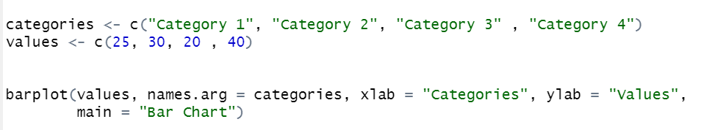

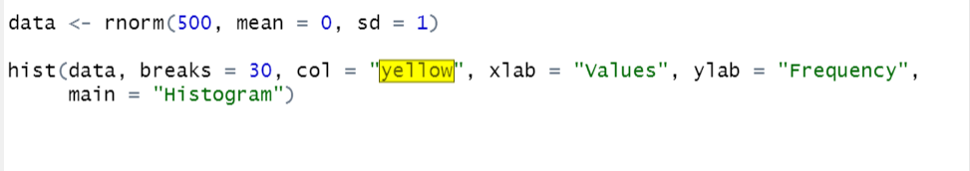

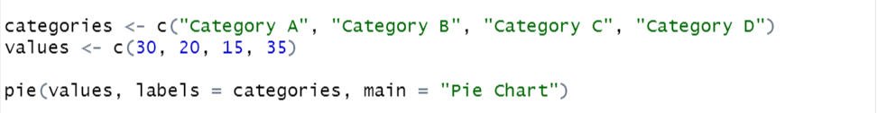

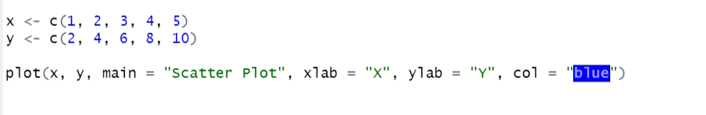

**Output:**

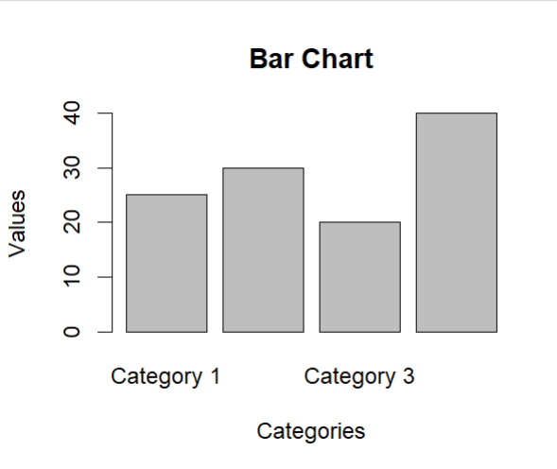

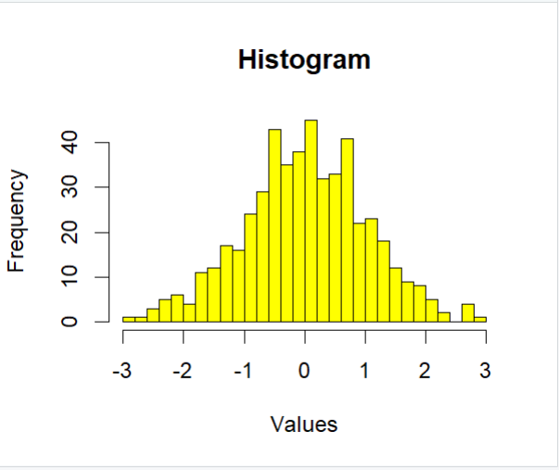

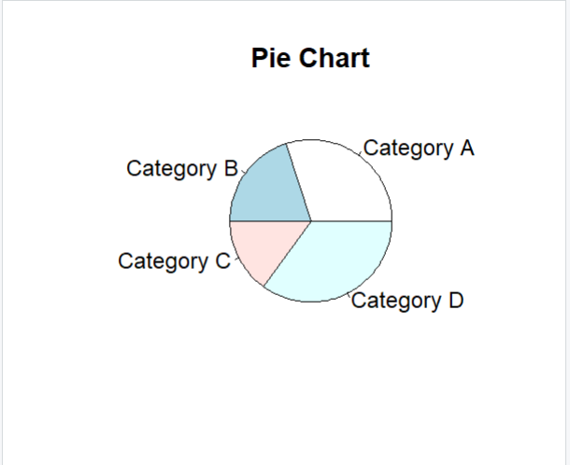

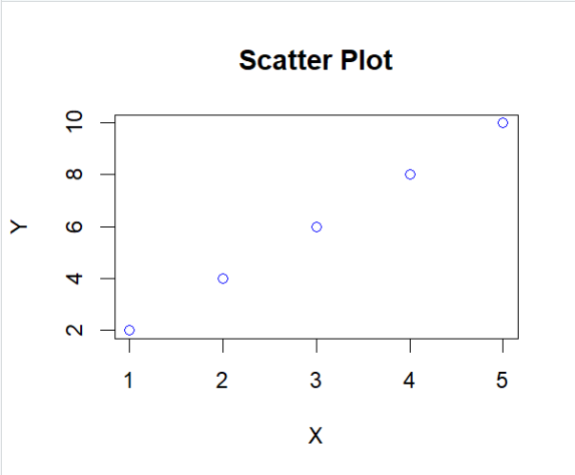

**Observation and Learnings:**

_____________________________________________________________________________